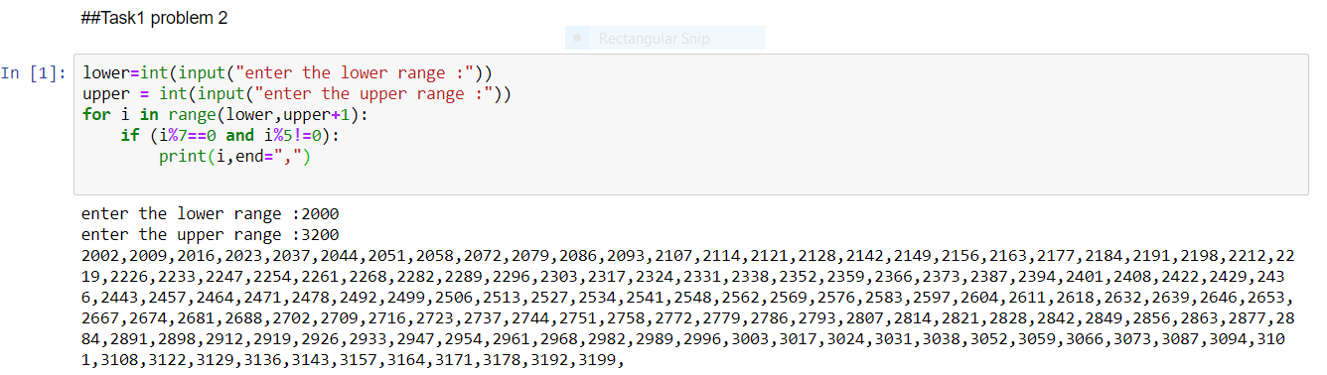

Task1,problem 3

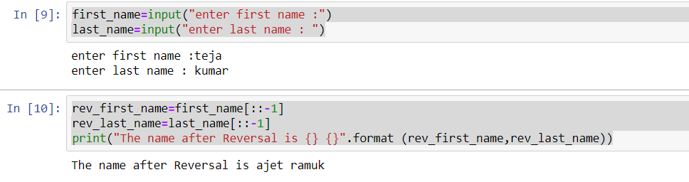

Task1,problem4

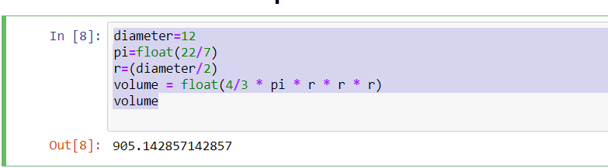

Task 2,problem 1

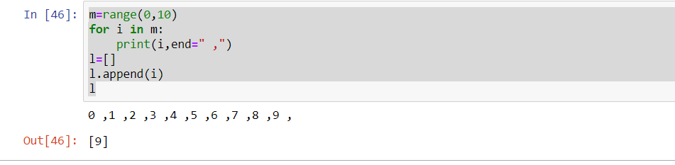

Task2,problem2

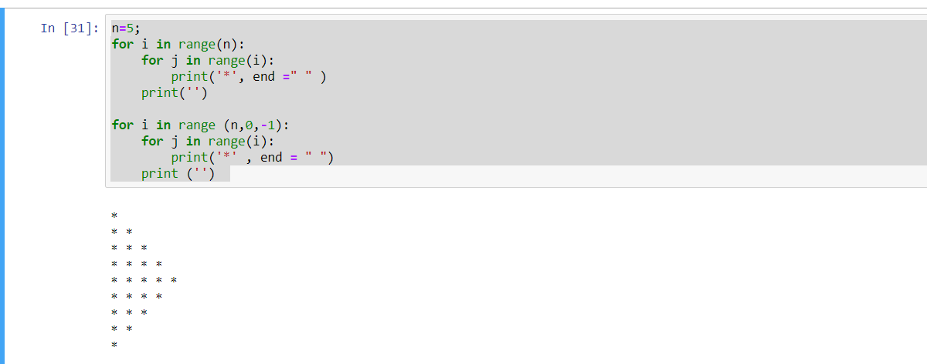

Task2,problem3

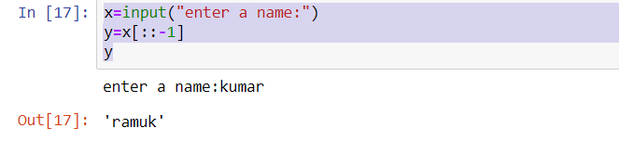

Task2,problem 4

